**Bash scripts_usecase**

1) write a script to print Hello wrold ?

#!/bin/bash

echo"Hello world"

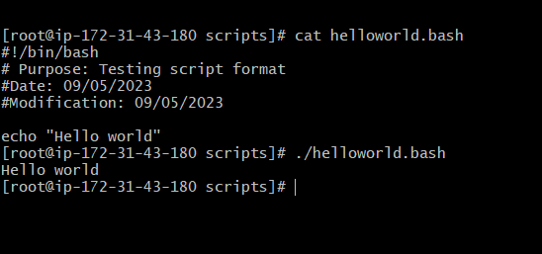

2) write a script to add 2 number

#!/bin/bash

Num1=10

Num2=3

((Sum=Num1+Num2))

echo "Sum = $Sum"

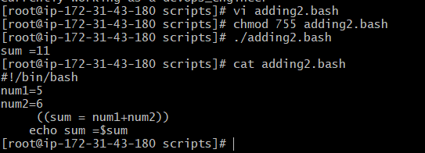

3) write a script to create a directory and check weather its created ?

#!/bin/bash

echo"to create a directory by name song"

mkdir song

echo"check weather its created or not"

ls -ltr

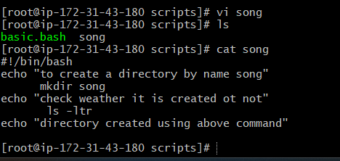

4) write a script to create multiple directory ?

#!/bin/bash

echo "create a multiple directory inside a directory"

mkdir -p opt/sample/devops/test

echo "check weather the directory test is created or not"

cd opt/sample/devops/test

echo "directory created"

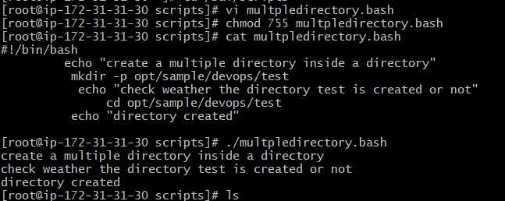

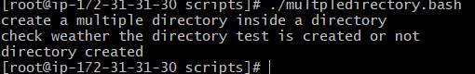

5) write a script using if statement ?

#!/bin/bash

read -p " Enter number : " number

if [ $number -gt 125 ]

then

echo "Value is greater than 125"

fi

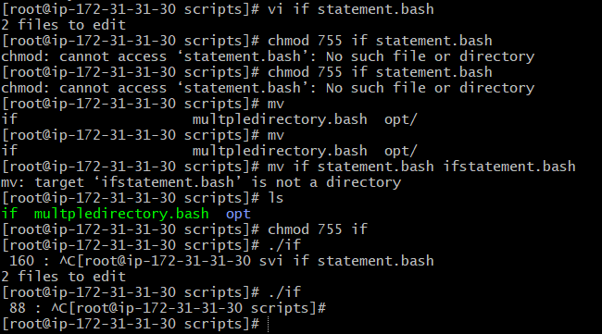

6) write a bash script to create a directory but need to check whether its already

there or not if directory not exists then directory has to created ?

#!/bin/bash

read -p "dir : " dir

if [ -d $dir ]

then

echo "$dir exists"

else

echo "$dir dosesnt exist"

mkdir $dir

fi

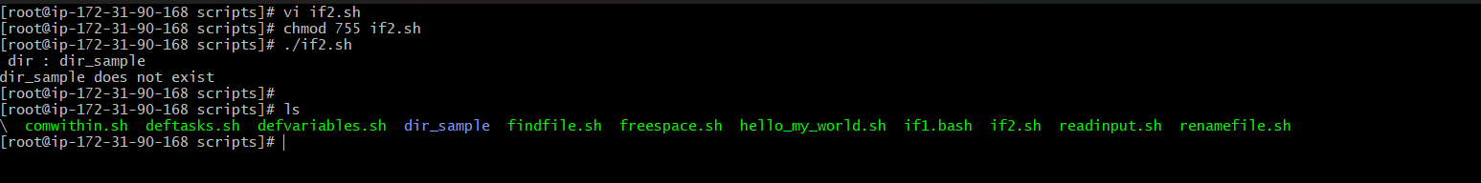

7)write script to check the given number is greater or not using if statement?

#!/bin/bash

if condition (greater than) true

if[10 -gt 3]

then

echo "10 is greater than 3)

fi

